The perimeter is distance you need to travel around a shape .
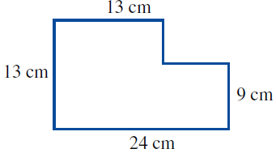
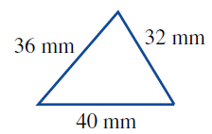
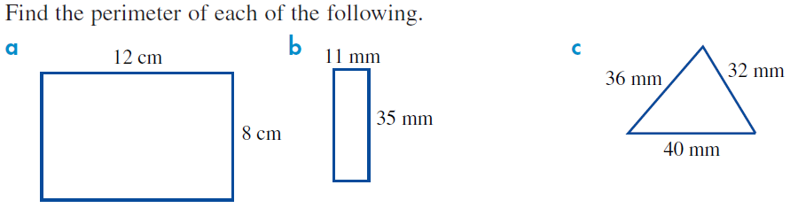

On circles the perimeter is called the circumference and is found using a formula. Circumference =2$×π×radius$
Find the perimeter for the following
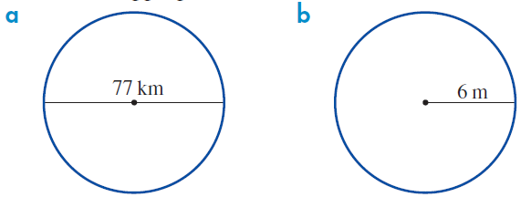

Area is the floor space a 2-dimensional shape has inside it. A good example is to think about how much carpet would you need to cover a floor.
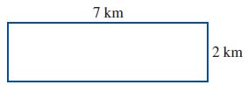
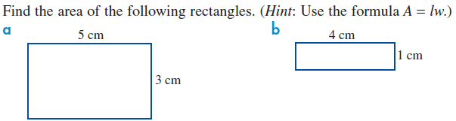

(Hint: Use the formula $Area= \frac{1}{2} (base ×height)$
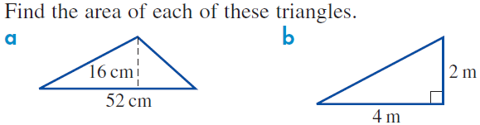

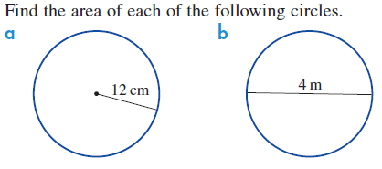
(Hint: Use the formula $Area= π×{radius}^{2}$

For complex (compound) shapes we need to break them up into smaller pieces, find the area of each piece and add them together.
